Project Plan

CITS3200 – Group B

Kieran Hannigan  
Alex Tonkin  
Ashwin D’Cruz  
Cameron Johnson  
Dean Cook  
Marcus Pham

Contents

Task List Timeline 2

Gannt Chart 3

Team Member Time Charts 4

Alex 4

Ashwin 5

Cameron 6

Dean 7

Marcus 8

Kieran 9

# Task List Timeline

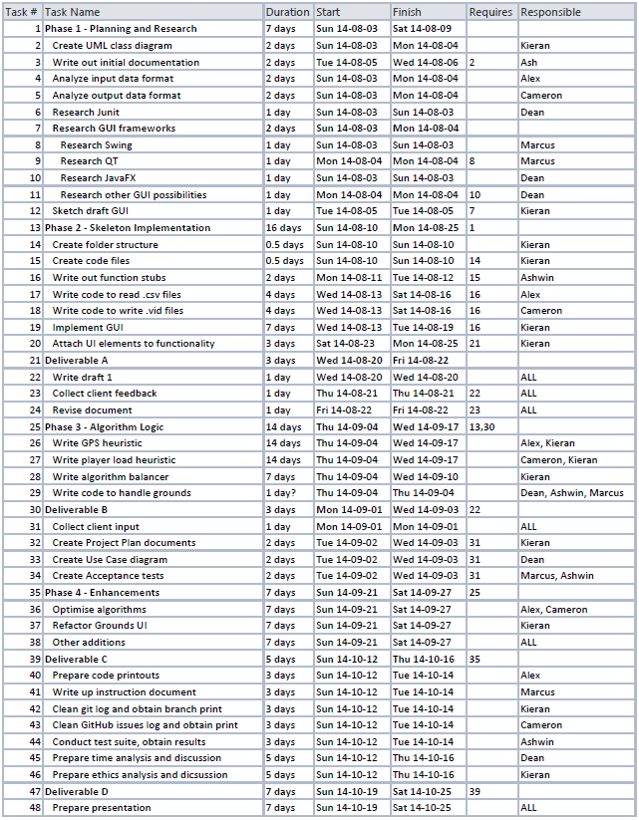

# Gannt Chart

Numbers correspond to task list.

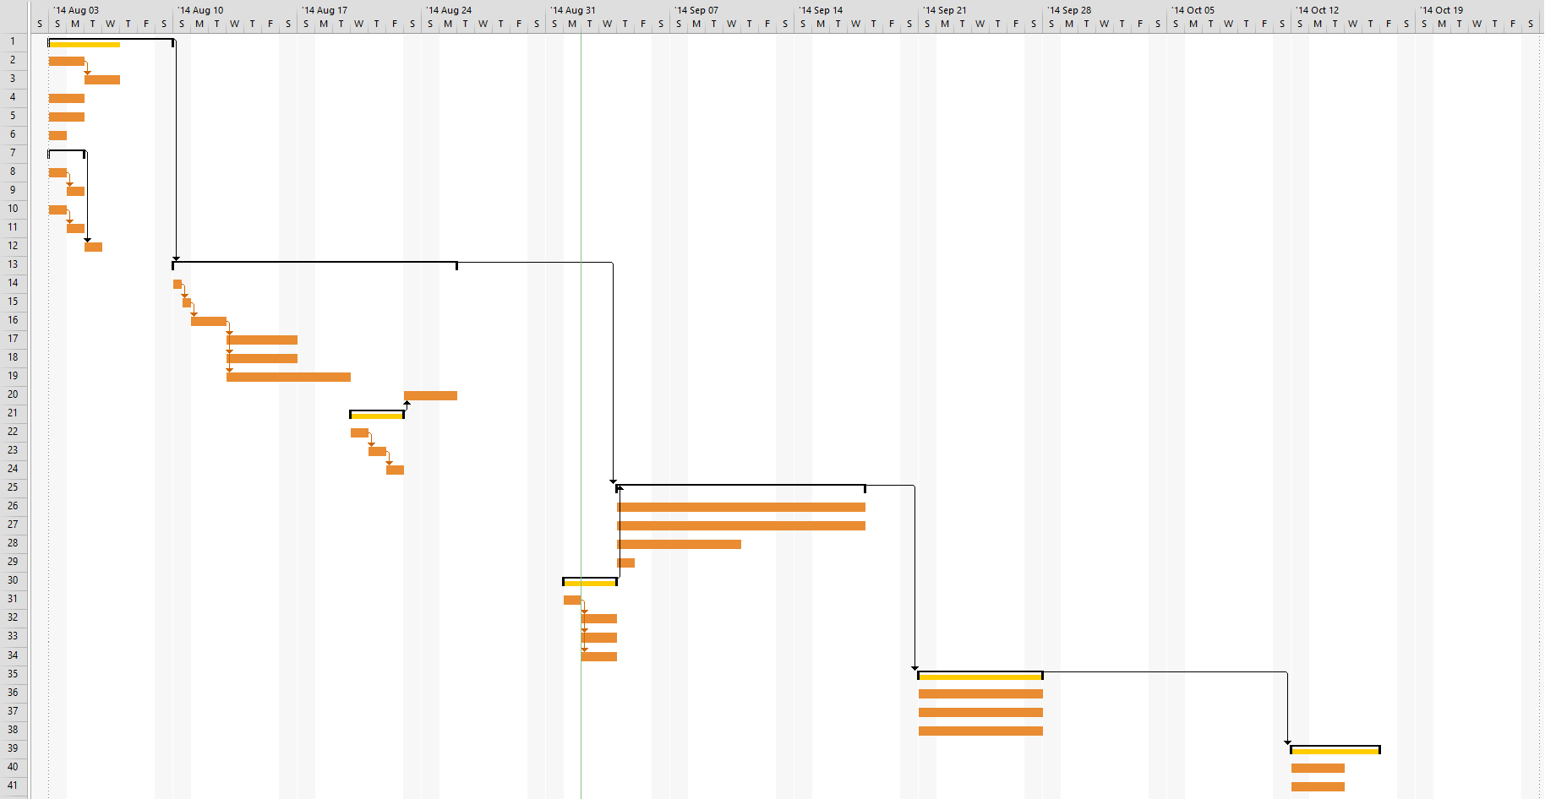

# Task Estimates and Time Charts

Broken down by member and deliverable.

## Alex

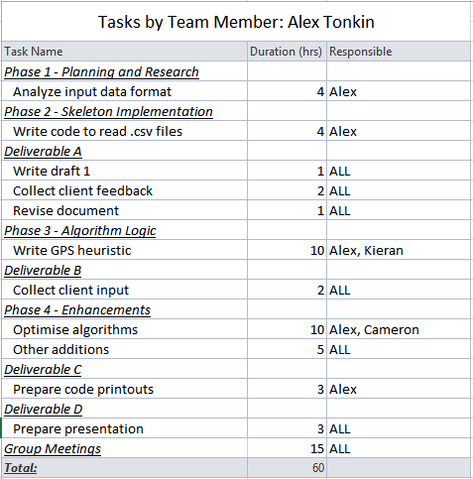

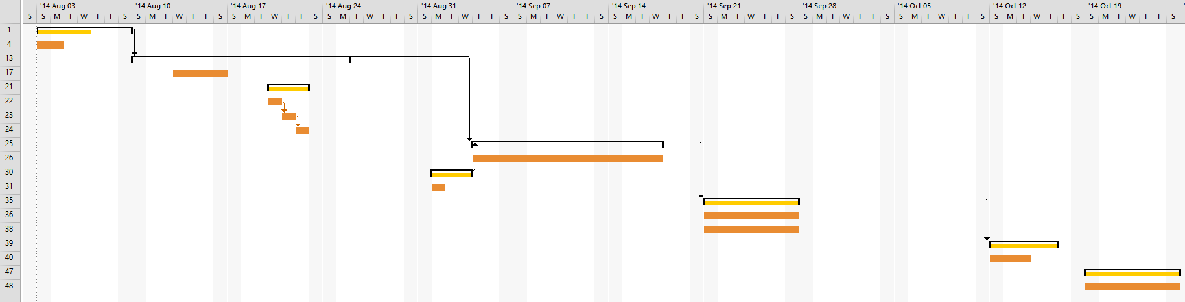

## Ashwin

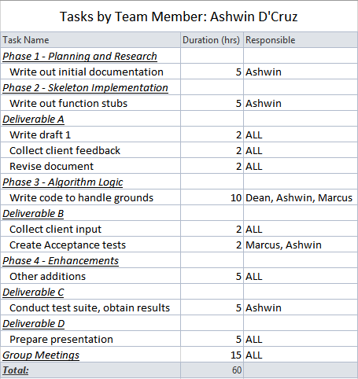

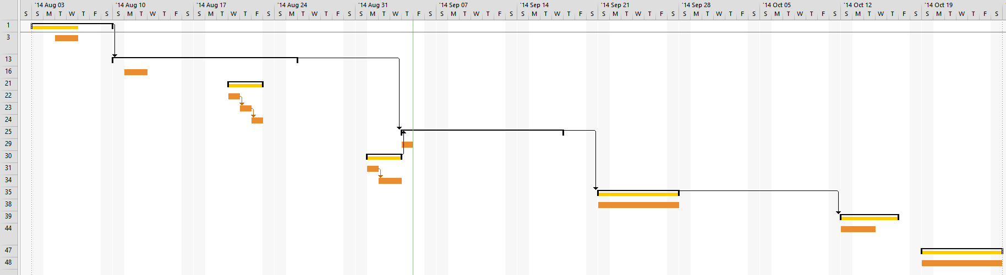

## Cameron

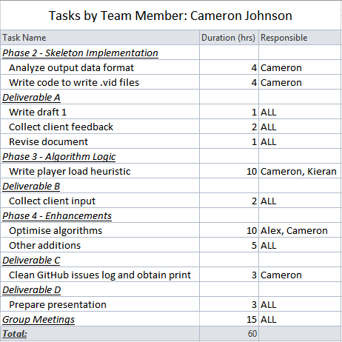

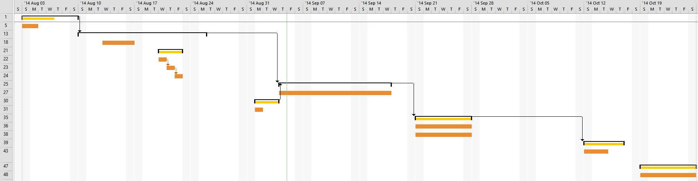

## Dean

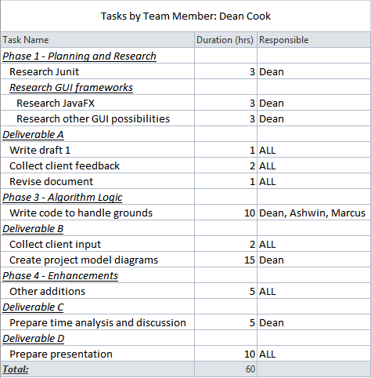

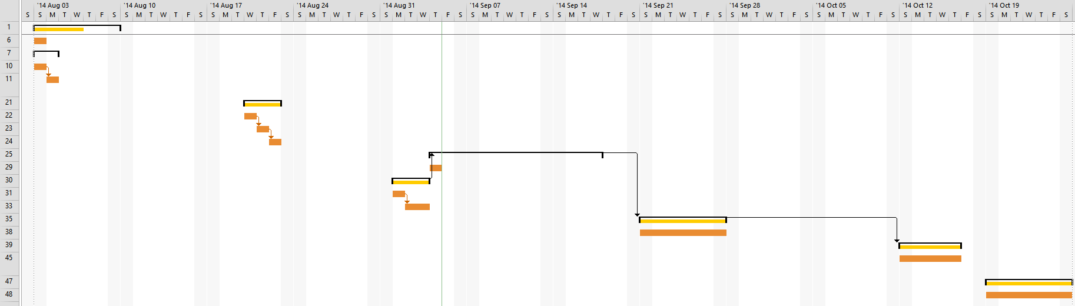

## Marcus

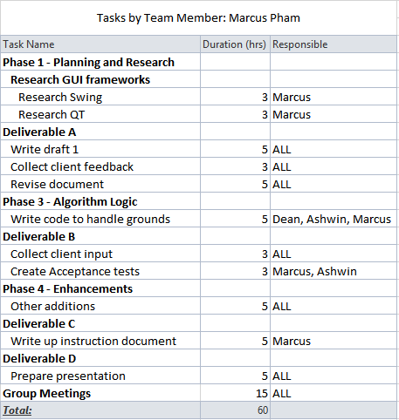

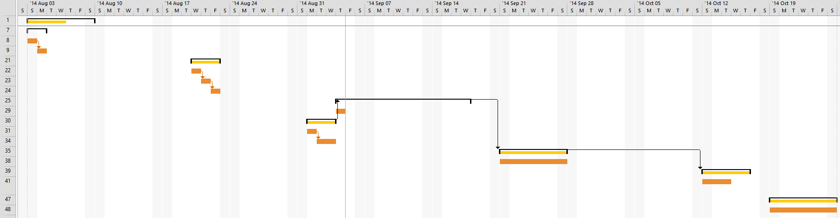

## Kieran

